1. 90% hands-on and 10% theory.
2. What is redis?  
   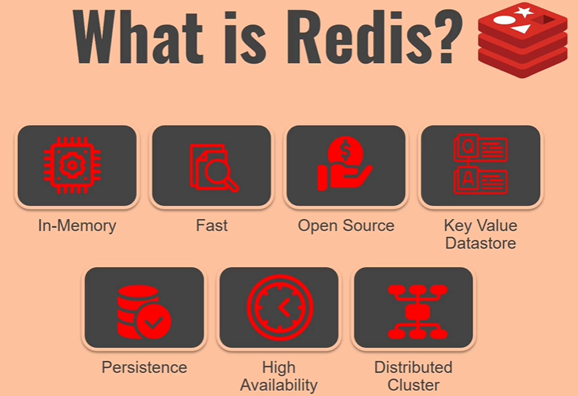
   1. **In-memory** db so fast as from reading and writing into the main memory is huge **fast** as compared to reading and writing into hard disk. It’ actually almost 10,000 times fast.
   2. It’s also very fast as compared to other in-memory db as it’s written in C language which is very close to machine.
   3. **Open Source**: No cost.
   4. **Key Value Datastore**: Whatever data we store in redis is in key-value pairs. So it’s more like a **dictionary**. Redis is **key-value Data Store**.
   5. **Persistence**: All the operations are performed on data in memory but we can store the data on hard disk too. When data is not available in memory, only then it fetches the data from the disk. When redis loads, it fetches the data from disk. And when new data is coming, only then it makes the new data also persistent that time only it’s going to perform right operations of keeping the data on disk. Yes data is **durable**. It provides **durability**.
   6. **High Availability:** Redis gives you option of high availability as there are many ways to set up for this. If you setup 3 servers and one of them goes down, then redis is going to be fully functional and your app is not going to get impacted from redis not being available.
   7. **Scalability**: **Distributed Cluster**: If you set up a redis cluster with six servers and in future you want to increase the number of servers to gain more out of radis, you can do that. Scaling up.
3. The Good thing is that configuring all of those things are very easy if you want to do the same thing using any other datastore technology. Redis is great simple.
4. Let’s understand some of the things in more detail. So when we said that this is in memory.  
   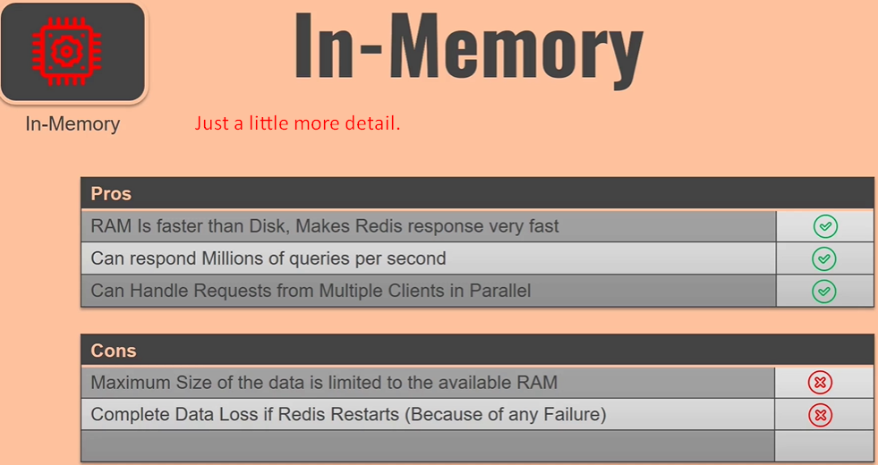
5. 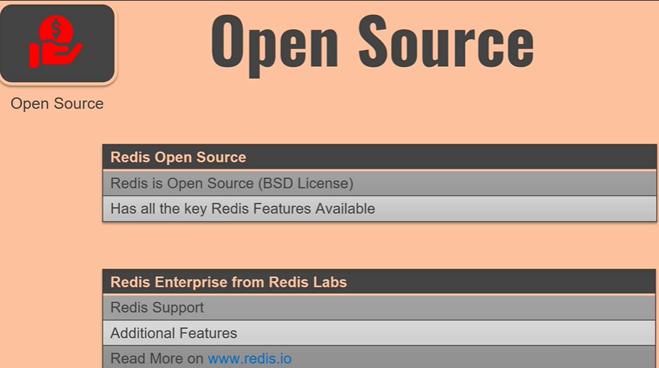
6. 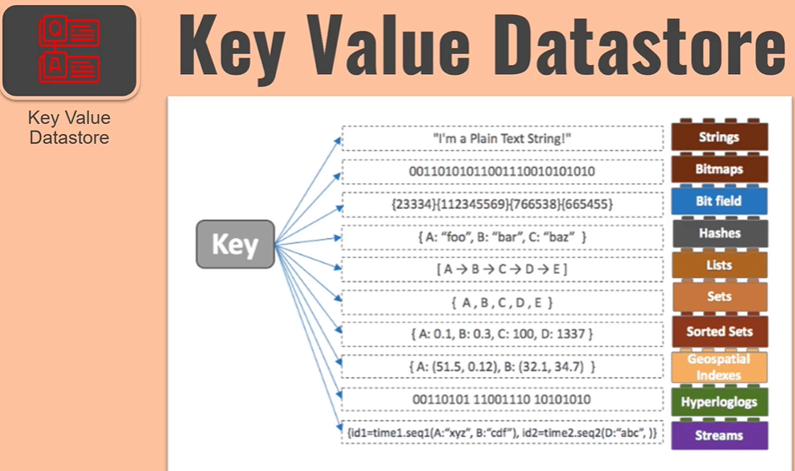
7. 